CO4_AT1

1. Job Scheduling with Deadlines
Aim:
To maximize the total profit by scheduling jobs before their deadlines using a greedy algorithm.
Algorithm:
- Store each job with its deadline and profit.
- Sort jobs in descending order of profit.
- Create time slots according to the maximum deadline.
- For each job, find the latest available slot before its deadline.
- Schedule the job if a slot is available.
- Add its profit to the total profit.

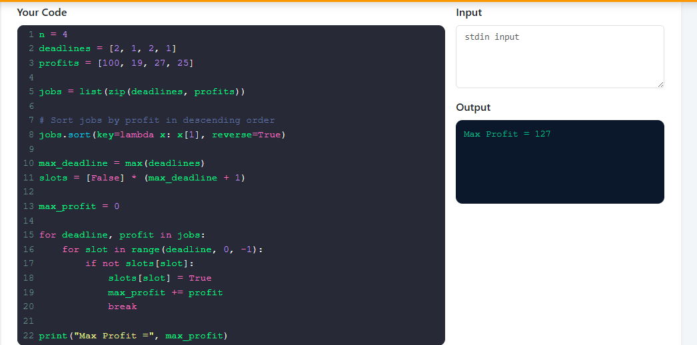

Result:
The jobs are scheduled optimally and the maximum profit obtained is 127.

2. Minimum Number of Jumps
Aim:
To find the minimum number of jumps required to reach the last index of an array using Dynamic Programming.
Algorithm:
- Initialize a DP array with infinity.
- Set dp[0] = 0.
- For each position, consider all reachable positions from it.
- Update the minimum number of jumps for each reachable position.
- Continue until the last index is reached.
- Return the value at the last index.

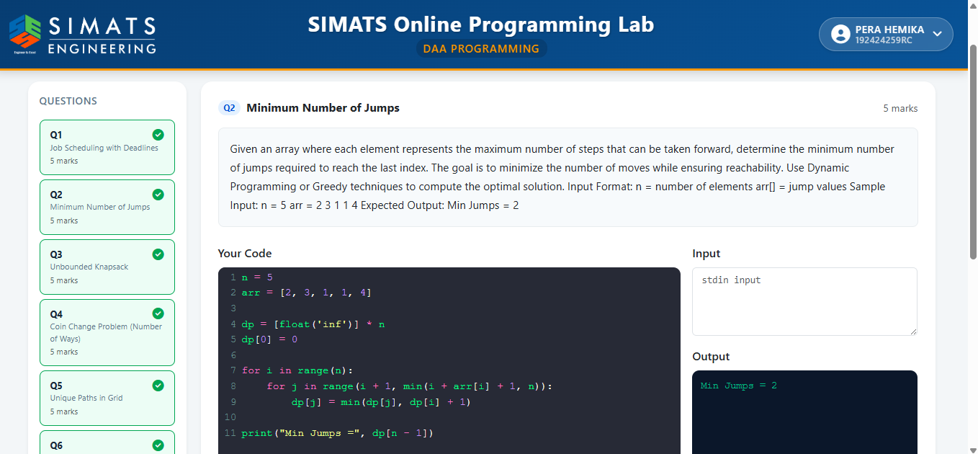
Result:
The minimum number of jumps required is 2.

3. Unbounded Knapsack
Aim:
To maximize the total profit within a given capacity when each item can be selected multiple times.
Algorithm:
- Initialize a DP array of size capacity + 1 with zeros.
- For every capacity from 0 to the maximum capacity:
- Check each item.
- If the item's weight fits, calculate the profit obtained by including it.
- Store the maximum profit for that capacity.
- Return the maximum profit for the given capacity.

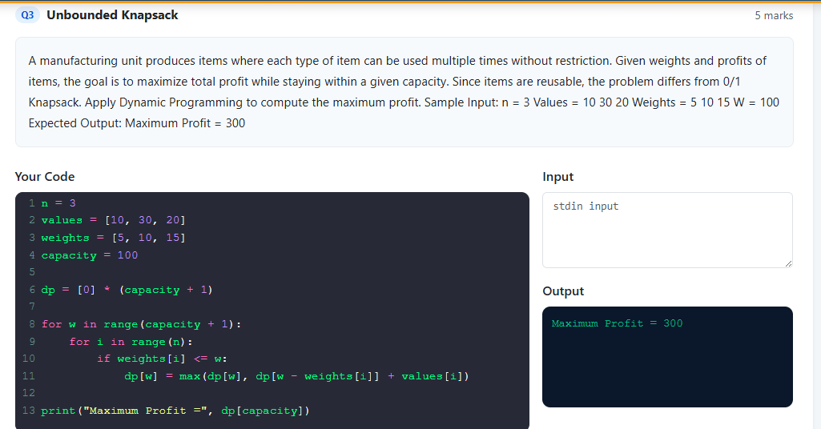
Result:
The maximum profit obtained is 300.

4. Coin Change Problem – Number of Ways
Aim:
To find the number of different combinations of coins that can form a given target amount.
Algorithm:
- Initialize a DP array with zeros.
- Set dp[0] = 1.
- Process each coin one by one.
- For every amount from the coin value to the target amount, update:
dp[amount] = dp[amount] + dp[amount - coin]
- The final DP value gives the number of ways.

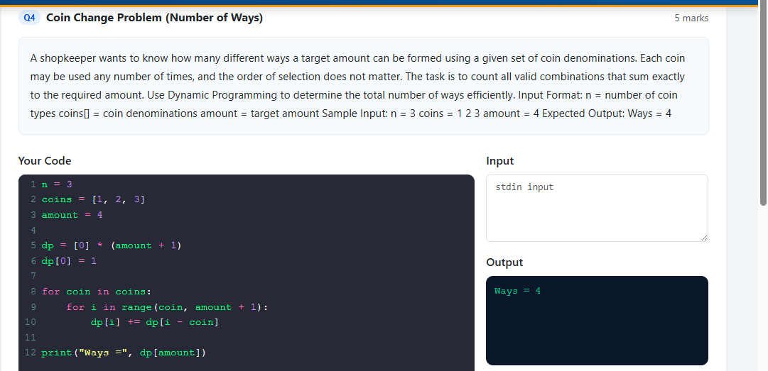
Result:
The target amount can be formed in 4 different ways.

5. Unique Paths in Grid
Aim:
To determine the number of unique paths from the top-left corner to the bottom-right corner of a grid.
Algorithm:
- Create a DP table for the grid.
- Initialize the first row and first column with 1.
- For every remaining cell, calculate:
dp[i][j] = dp[i-1][j] + dp[i][j-1]
- Continue until the bottom-right cell.
- Return the value of the bottom-right cell.

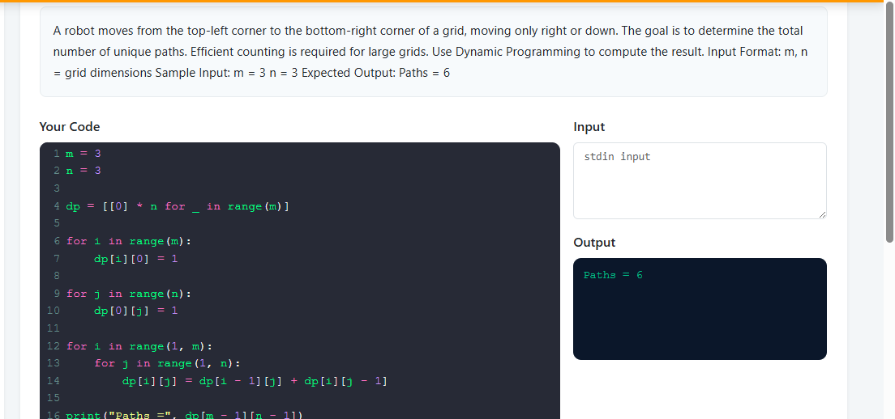
Result:
For a 3 × 3 grid, the number of unique paths is 6.

6. House Robber Problem
Aim:
To maximize the amount of money stolen from houses without robbing two adjacent houses.
Algorithm:
- Create a DP array.
- Set the first two values based on the first two houses.
- For every remaining house, choose the maximum of:
  - Skipping the current house.
  - Robbing the current house and adding the amount from two houses before.
- Store the maximum value.
- Return the final DP value.

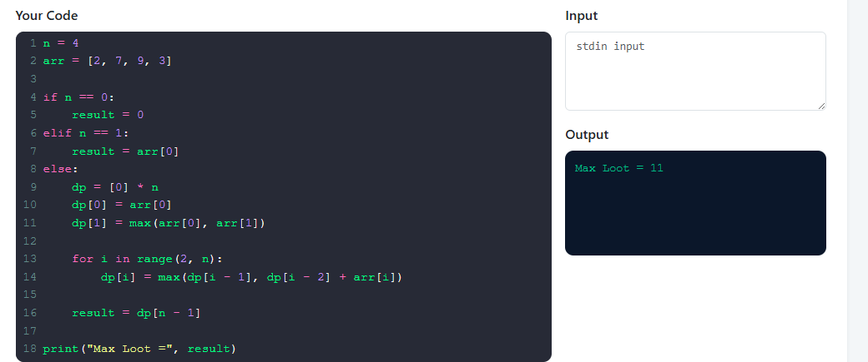
Result:
The maximum amount that can be robbed is 11.

7. Maximum Profit with K Transactions
Aim:
To find the maximum profit from buying and selling stocks with at most K transactions.
Algorithm:
- Create a DP table for transactions and days.
- For each transaction, track the maximum profit up to each day.
- Maintain the best difference between previous profit and stock price.
- Update the DP table using the current stock price.
- Repeat for all allowed transactions.
- Return the maximum profit.
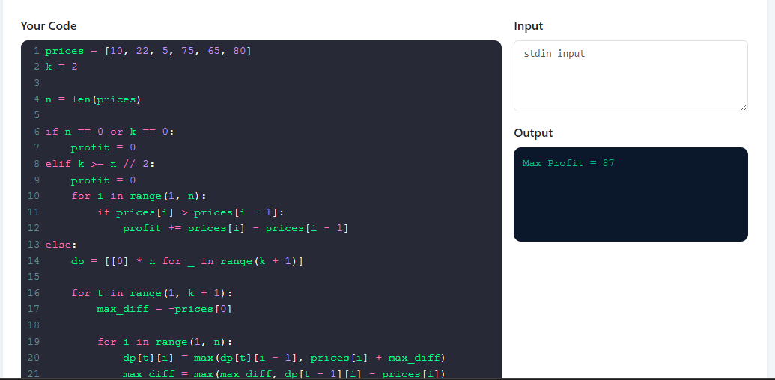
Result:
With at most 2 transactions, the maximum profit is 87.

8. Count Subsets with Given Sum
Aim:
To count the number of subsets whose elements add up exactly to a given target sum.
Algorithm:
- Initialize a DP array with zeros.
- Set dp[0] = 1.
- Process each array element.
- Traverse the DP array from the target sum down to the current element.
- Update:
dp[sum] = dp[sum] + dp[sum-element]
- The value at the target sum gives the number of valid subsets.

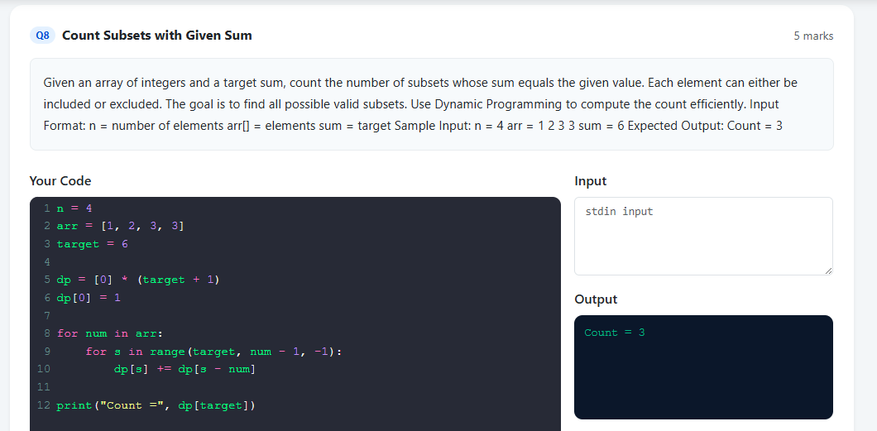
Result:
For [1, 2, 3, 3] with target 6, the number of subsets is 3.

9. Minimum Cost Climbing Stairs
Aim:
To find the minimum cost required to reach the top of a staircase when one or two steps can be climbed at a time.
Algorithm:
- Create a DP array for the minimum cost to reach each step.
- Initialize the starting conditions.
- For each step, calculate the minimum of:
  - Cost from the previous step.
  - Cost from two steps before.
- Continue until the top is reached.
- Return the minimum cost.
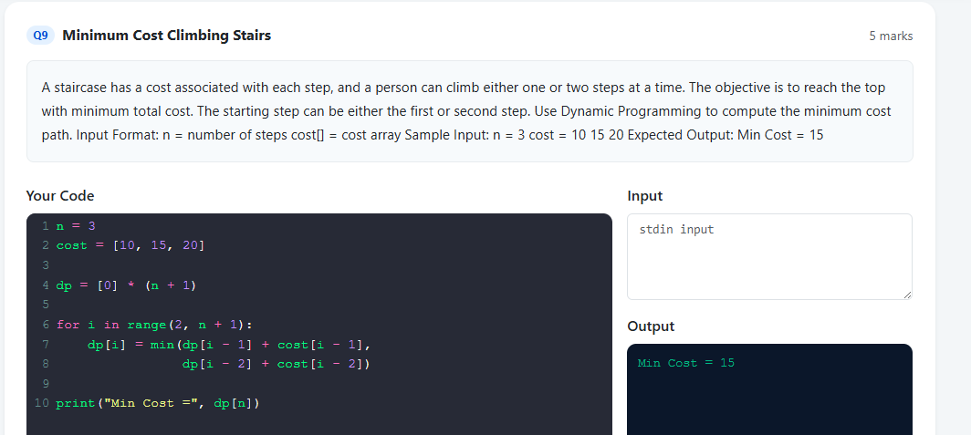
Result:
The minimum cost to reach the top is 15.

10. Fibonacci with Memoization
Aim:
To calculate the nth Fibonacci number efficiently using Dynamic Programming and memoization.
Algorithm:
- Define a recursive Fibonacci function.
- Store already calculated Fibonacci values in a memoization dictionary.
- Return n when n is 0 or 1.
- Before calculating a value, check whether it is already stored.
- If not stored, calculate it recursively and save the result.
- Return the nth Fibonacci number.
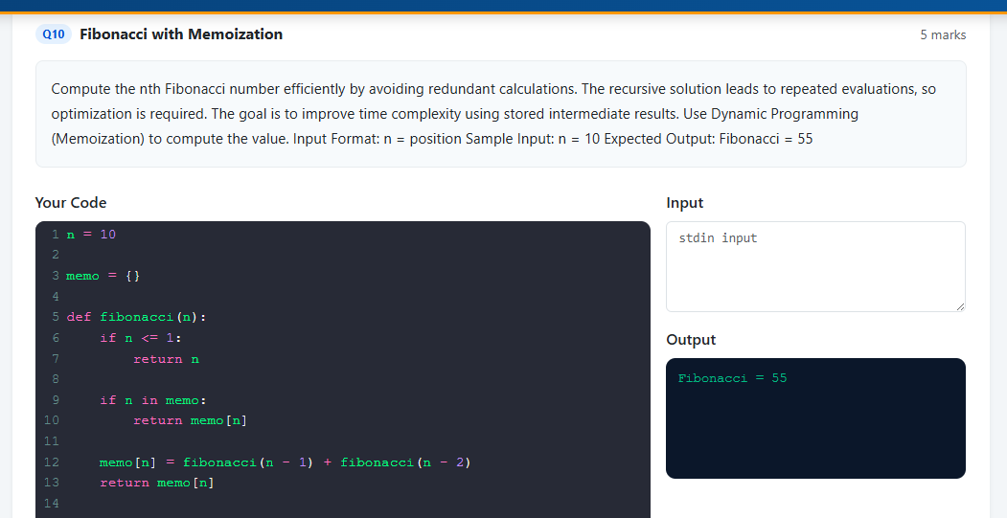
Result:
For n = 10, the Fibonacci number obtained is 55.

